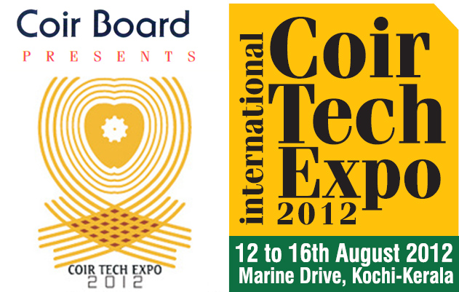

INTERNATIONAL COIR TECH EXPO 2012
Marine Drive, Ernakulam
12th to 16th August 2012

STALL RESERVATION FORM
1 | THE PARTICIPANT:
 | Individual |  |  |  | Partnership |  |  | Company |  |  |  |  | Co-op.  Society |  | Others
 | 1. The name and complete postal  address of the participant: ____________  _________________________________  _________________________________  _____________PIN_________________ |  |  |  |  |  | Phone No.  (with area code)
 |  |  |  |  |  |  | Mobile No.
 |  |  |  |  |  |  | Fax No.
 |  |  |  |  |  |  | e-mail
 |  |  |  |  |  |  | web
 | The executive who will liaise with the exhibition:
 | Name
 | Designation
 | Phone No.
 | Mobile No.
 | e-mail
2 | Short Name of the Firm/Company (FASCIA)
3 | Details of Exhibits:
4 |  | a) Requirement: Stalls |  |  |  |  |  |  |  |  |  | No. of stalls
 |  | Premium |  |  |  |  |  |  | Rs.25,000/- per stall
 |  | Special |  |  |  |  |  |  | Rs.50,000/- per stall
 |  | b) Requirement: Bare Space
 |  | c) Requirement: Out door Open Space
5 |  | Signature: |  |  |  |  |  |  |  | Name
 |  |  |  |  |  |  |  |  |  | Designation
Place: Office Seal

Date:
NOTE: The D.D./Cheque towards participation fee may be drawn in favour of the Secretary, Coir Board (Coir Tech Expo Account) payable on any nationalized Bank in Ernakulam.

